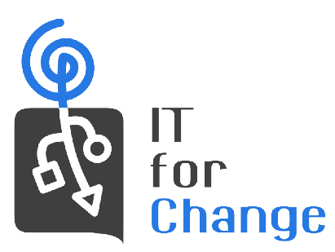

To
Shri Shaktikanta Das
Governor
Reserve Bank of India
Mumbai-400 001.
governor@rbi.org.in
Thursday, 18 May 2023

Subject: Action taken regarding RBI’s outsourcing of AI based supervisory technology – Serious concerns regarding

Dear Shri Das,
We write to follow up on the letter we wrote to you on 2, February, 2023, about the RBI outsourcing AI based supervisory technology (attached). We would very much like to know if the RBI was able to form a final view on this subject and whether our views were taken into consideration.

We also take this opportunity to highlight the news that PWC used confidential information gained from its work with the Australian government for its own commercial advantage against the interests of their Government client (also attached). Thus, they shared confidential information about Government moves on taxation related matters which helped their global clients take pre-emptive measures to evade taxes. PwC is now facing criminal and corruption investigations.

This may not be treated as a one-off egregious act. Many similar cases have been brought to light, particularly in the eminent Economist Mariana Mazzucato’s book “The Big Con” which exposes the machinations of the Consultancy industry on a global scale and the impact it has in “infantilising” Government capacities. This is precisely what we had warned against in our letter to you. It must be remembered that PwC is one of the seven global corporations short-listed by RBI. But this behavior is common to the Big 4 Consultancies as it is their business model.

The above is a clear example of the conflict of interest characterising the Consultancy industry and further highlights the danger of outsourcing critical and sensitive data to foreign entities which have no stake in our National Economic Security. Sharing confidential information in violation of non-disclosure contracts is bad enough, but sharing of not just data but also the intelligence that comes from India's vast financial data –is far more damaging. For instance, in the worst case scenario, this data/ intelligence can be weaponised to impact National Economic Security, as it can be used to obstruct the smooth functioning of the nation’s financial system. All kinds of undetected biases can be built into “Black Box” AI producing outcomes that would not necessarily be aligned with our national interest. Finally, the intelligence gathered from this same data, which should be the property of the Indian authorities and which should only be processed and converted into high-value products indigenously - can be sold back to us (and other clients) at a premium cost.

We, therefore, once again urge you to reconsider the current process involving only seven global consultancies, and look at partners from within India, and if needed a consortium of them. RBI should also enhance its internal capacities in this regard and further involve a larger slate of academic and other non-government actors, in an open and transparent process, as undertaken by the European Central Bank, about whose practices we gave detailed information in our original letter. We remain available for any help in this regard.

Sincerely yours,
Parminder Jeet Singh
Executive Director, IT for Change

Sharad Sharma
Co-Founder, iSPIRT/ India Stack

Smita Purushottam
Chairperson SITARA

