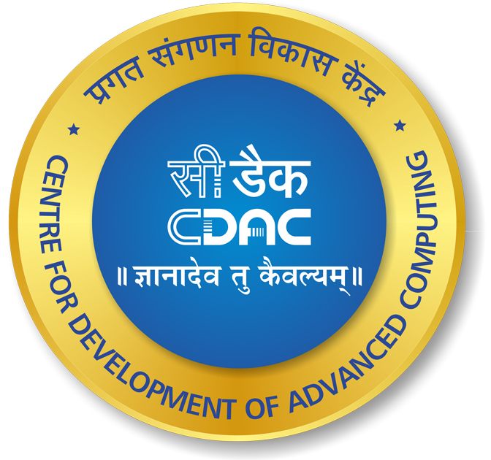

To
Prof Ajay Sood
Principal Scientific Advisor to GoI
New Delhi
12 September 2023
Copy to:

Shri P K Mishra  Principal Secretary to PM  PMO, South Block, New Delhi, 110011 | Shri Ashwini Vaishnaw  Minister of Railways, Communications and  Electronics and Information Technology
Shri Ajit Doval  National Security Advisor | Dr. S. Jaishankar  External Affairs Minister

National Deep Tech Startup Policy 2023
Including Building of Sovereign Indian Compute Stack and Related Suggestions

Dear Sir,

At the outset we would like to (i) commend your Draft National Deep Tech Startup Policy 2023 and (ii) take this opportunity to offer inputs/ recommendations at A-G in response to your invitation:

A. Sovereign Compute Stack

India must consolidate its global leadership, demonstrated by the path-breaking G20 Summit, by developing sovereign technological capabilities. This will boost national pride and National Security and promote exponential economic growth. China aims at world science and technology leadership by developing core technologies and is already reportedly leading in 37 out of 44 technologies according to a US State Department sponsored report. Technological sovereignty is central to the National Security doctrines of all major Powers so we should not mistake “collaborations” pursued by some of India’s biggest companies with Nvidia for sovereign AI, as Nvidia is only looking for alternative markets, after the Chinese market and even the markets of some purported US allies were embargoed. Moreover, Big Data, which is being shared freely with the Big 4 and Big Tech by Govt departments, is the driver behind every 'collaboration' sought with India. This leads to the (i) bulk of the value running into trillions of dollars generated by Indian/ Indian origin engineers and the R&D centres located in India working on deep tech capabilities, and (ii) contracts for Data Analytics - being captured by foreign entities.

Indigenous sovereign technological capabilities which our proposal will ensure - besides being vital for National Security - will ensure domestic capture of these trillions of dollars and measurable development of national capabilities.

We accordingly recommend one such project for inclusion - a Sovereign Compute Stack (or SCS) – as the cornerstone of the Deep Tech Policy. The SCS will include microprocessors, AI, Clouds and Servers and devices, all with Indian IPR ownership. The SCS would:

- Pre-empt Export controls: India is no stranger to export controls, which are now being levied even against traditional US allies like UAE and Saudi Arabia.
- Pre-empt Digital Colonisation in terms of foreign capture of India’s Digital Infrastructure: Big Tech’s power is increasing exponentially and will soon eclipse that of Nation States. Sovereign AI capabilities and national ownership of critical data will ensure (i) Indian data stays Indian, (ii) Data Analytics contracts are given to Indian Companies (India must encourage its own companies to develop Data Analytics at scale) and (iii) Indians get the first mover advantages and avenues for multi-million/billion-dollar innovations.
- Ensure Indian companies stay Indian: At present, the minute a valuable technology is produced, the firm either relocates abroad or is acquired by Big Tech. We can prevent this cumulative loss of trillions of dollars by deploying the SCS.
- Secure our cyberspace: Based on open-source hardware and software it will ring-fence the deployment at a Country level, ensuring there are no gaps from a Cyber Security perspective. It will also lay the foundation to meet the future needs of Government in cryptography as China is developing quantum capabilities at break neck speed.

For all these reasons, India must prioritise indigenous capability development in critical computing technologies - with the State taking the lead in partnership with high-tech indigenous private enterprises, as in the US model. This will span at least 10 years if not more, if India starts now.

Disclaimer: We are not aiming at cutting ourselves off from advanced economies, but suggesting that this effort to build National Technological Capability be undertaken in parallel with our prospering globalised software sector.

Thus, our plan to create an SCS includes building the following:

- A family of processors based on RISC-V architecture for:
- Embedded devices starting from TV remotes to advanced robotics, rocket and spacecraft control systems, etc.
- All kinds of Mobile, Laptop and Desktop devices for the rural masses, the goal being to build products like the iPhone, iPad, MacBook Air and iMac at about 15-30% of current retail prices.
- Servers and Super-compute applications: Indian organisations like CDAC can build large scale servers for running cloud infrastructure as a standardized platform for Govt. departments at about 15% of the current prices on AWS/Azure/ GCP. This can enable massive digitization of Govt. records like IT, GST, Aadhar, MNREGA, etc., and novel uses, at a price that is unthinkable today. At present critical data is hosted on foreign Clouds and servers and constitutes a gift to foreign entities, apart from presenting a national security vulnerability. Also, expanded national use will come at a very high cost which the current foreign based capacity cannot handle.
- A Supercomputer that can do 100 Exaflops: CDAC plans to build the Param Shankh using the ARM architecture which requires us to pay license fees. Our proposal is to use RISC-V which is open source and free.
- Cloud native stack with AI applications: An Indian General AI would make us independent in an AI-dominated era. To this end we can build an AI accelerator of the requisite number of cores to run AI workloads (both training as well as inferencing) at Super-compute scale. An AI engine that can run massive LLMs like ChatGPT at speeds 100x of the current GPU speeds of NVIDIA, at a price that is a fraction of that of NVIDIA and an energy consumption that would be enviable, can provide the Green AI Compute.
- A developer tool chain consisting of Compilers and other Developer Tools for software developers, so that new software can be developed for any platform. These are tools that every developer uses to translate their human readable program to the machine language, which is in zeros and ones.
- A Dynamic Binary Translator (DBT) on the lines of Rosetta from Apple, for running applications from the Windows/x86 platform on the new platform. This tool will help automatically translate existing software to run on new platforms. Apple and HP have used this in the past for migrating to new compute platforms and one of the authors of this report has been directly involved with the development of one of those efforts.

A priority component of the ecosystem would be incentivisation of Indians to register their IP in India and contribute to Atmanirbharta. A presentation going into the details is attached.

Funding model

Instead of spending the hundreds of million dollars the IBM CEO has talked about to merely continue importing hardware and AI, we can build prototypes of sovereign compute infrastructure including cutting-edge AI capabilities - with Government in the lead to “crowd in” private investment, as in the successful InQTel model in the US – for the same amount. Forward looking Industry leaders like the Tatas, Kalyanis and Mahindras, can partner with Government for a joint investment of only US$500 million (ISRO has converted to public-private partnership) to build the initial prototypes through an SPV. Production can be scaled via an IPO after prototype deployment. The time frame envisaged is about 3 - 4 years to execute the prototype stage. Full production scale will take another 1.5 years.

GoI has already launched laudable but separate initiatives in sovereign AI, supercomputers, quantum technologies, semiconductors and 4G/5G. These must be synergised under one National Mission to ensure India emerges as an independent technological power and your esteemed Office which is charged with both advisory and coordination roles is the ideal one to take the Mission forward. We can leapfrog, just as we did with UPI, which iSPIRT, one of the signatories to this letter, helped to create and which is in demand around the world. This initiative will reverse the colonial digitisation of India. It will take several years to fructify but will yield exponential benefits of trillions of dollars for the country.

***

Our other suggestions for the Draft Deep Tech Policy are as follows:

- Include a target to increase R&D expenditure from the current 0.65% of GDP to at least 1.5% by 2025.
- Expand the extent and definition of deep-tech: The policy must extend incentives and support to any Indian company that produces any advanced digital, embedded or manufacturing technology that helps India become self-reliant in 4G, 5G, 6G, the defence industry including aero-engines, intelligentised weapons and other weapons systems, AI, supercomputers, semiconductors, cloud computing, novel technologies, etc.
- Provide tax incentives to entities that procure indigenously developed technologies and restore tax-breaks for R&D intensive companies.
- Consider/ promote the following as models for deep-tech projects:
- The resoundingly successful co-funding model for Covaxin vaccine production
- The ISRO model.
- The InQTel model which can be repurposed for India’s aims. This requires an initial investment by Govt to crowd in private investment for building sovereign technological capabilities.
- Vigorously leverage GOI’s directives on domestic procurement / Preference for Make in India: The Draft has rightly emphasised domestic procurement as a lever for promoting deep tech. Implementation and oversight of GOI’s directives on domestic procurement/ Preference for Make in India with enforceable penalties for undermining it must be included prominently in the Policy. After Shri Ashwini Vaishnaw broke with tradition and insisted on domestic procurement for the BSNL tender, Indian high-tech companies started to build the first indigenous 4G network in the country. Similarly, ISRO’s success and cost effectiveness is first and foremost due to R&D and procurement of indigenous equipment. But tender specifications in other Govt agencies including contracts for the Big 4 are still bypassing Government directives and our recent requests for their re-examination have led nowhere.
- Vigorously implement and expand the Design-led Incentive Scheme (not the PLI which does not encourage domestic technology development) and the TDFs for creating Deep Tech capabilities

Caution: All the above (A-G) will be opposed strenuously by vested interests wedded to foreign solutions and will requires visionary steering by our Leadership to achieve Hon’ble PM’s Atmanirbharta goals.

iSPIRT, SITARA and other esteemed volunteers are networks of like-minded engineers, high-tech companies, former and serving civil servants, academics, and other luminaries who aim to build Atmanirbharta in technological leadership. CDAC is a highly respected Government entity which is working towards development of sovereign tech capabilities. iSPIRT needs no introduction as the creator of the India Stack that powers UPI.

We request an opportunity to meet you and answer any questions. We would be honoured to be associated with you in the task of building a technologically advanced nation.

With best regards,

Sharad Sharma
Co-Founder, iSPIRT/ India Stack

Smita Purushottam
Chairperson SITARA
The Science, Indigenous Technology & Advanced Research Accelerator

Ayonam Ray
Director
RRLogic Systems Pvt Ltd

Parminder Jeet Singh

